AMARK RATINGS PRIVATE LIMITED
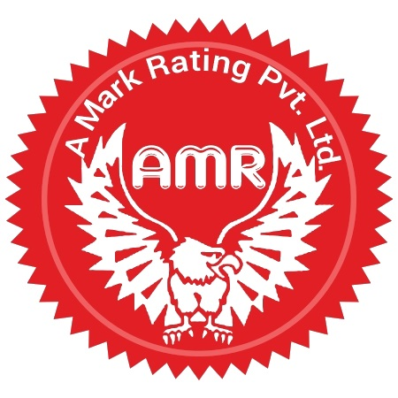

INSPECTION DIVISION, BHOPAL

FEEDBACK FROM THE COMPANY THAT HAS BEEN INSPECTED/AUDITED

1. Name of the Company:
2. Scope of Audit:
3. Date(s) of Audit:
4. Performance rating

Clause | Particulars | Evaluation
Clause | Particulars | Yes | No
4.1 | Quality of Audit
4.1.1 | Did you get the Audit intimation sufficiently in advance?
4.1.2 | Was the Audit carried out as per the programme?
4.1.3 | Did the team leader brief you about the methodology of Audit?
4.1.4 | Were the issues raised relevant, based on requirements / facts
4.1.5 | Did the issues add value in terms of improving the company processes?
4.1.6 | Did the Audit team evaluate your system sufficiently to come to a conclusion?  (Please highlight any key concerns missed out by the team)
4.1.7 | Did the Audit team check relevant records to verify and collect evidence of compliance?
4.1.08 | Was the Audit team impartial and fair in Audit?
4.1.09 | Was the team knowledgeable about the standard and Audit techniques
4.2 | Quality of Sampling
4.2.1 | Were the representative samples taken by the Audit team?
4.2.2 | Were the samples properly coded and counter signed by you representative?
4.2.3 | Were the counter samples left with you?
4.3 | Quality of communication and response
4.3.1 | Were your communications replied to promptly?
4.3.2 | Did you get sufficient info about the Audit before Audit?
4.3.3 | Did you get the Audit reports in reasonable time from the date of Audit?
4.3.4 | Were you satisfied with the speed of decision making by AMARK auditors?

5. General
5.1 What would you suggest that we do differently?
5.2 Overall service rating

Excellent (5) Very Good (4) Good (3) Average (2) Poor (1)

Note-Please send the filled up form to CEO inspection division in a sealed envelope.

Name of company Representative:
Designation:
Date:

